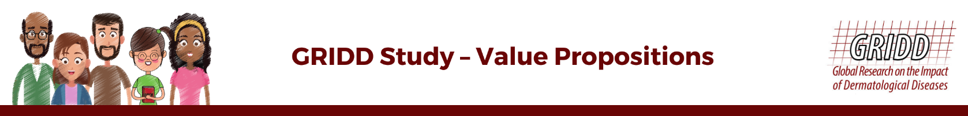  
  
We’ve made it as simple as ever to help communicate the importance of participating in the GRIDD Study. Each statement highlights how participation can bring about positive change, benefiting not only themselves but millions with skin conditions worldwide.

The significance of the GRIDD Study touches on several areas of importance including mental-health, treatment affordability, health care accessibility, and more. Choose from a wide range of statements that speak most to **your audience.**

Alongside these new value proposition statements, our team has designed blank images that can be co-branded to boost patient participation.

**The materials in this document have been created to inspire, motivate, and encourage patients to actively contribute to our ground-breaking GRIDD Study. Don’t miss out on having your patient community represented in the data.**

**INSTRUCTIONS:**

* Choose statements that resonate most with your audience.
* Copy and paste the statements to use in your chosen communication channels: WhatsApp, social media channels, email, blog post, newsletter etc.
* Use the official Study URL: <https://globalskin.org/GRIDDStudy> and the hashtag #GRIDDStudy to amplify reach and create a unified voice.
* Personalize one of our blank social media cards! Copy any statement below and paste it in the white space in the center of our blank cards (found on our [website](https://globalskin.org/component/content/article/78-gs-2019-content/588-gridd?Itemid=1710)).
* Co-brand the cards with your organization's logo to enhance authenticity and trust. Add your logo in the top center portion of the image for maximum visibility.
* If applicable in your country, we encourage you to translate the statement into one of the Study’s 17 languages so that your patient community can respond with ease.

**GRIDD STUDY MESSAGES BY FOCUS AREA**

**Mental Health**

* Feeling judged for your skin condition? You're not alone. Join our GRIDD Study to make the world understand your struggle.
* *<Name of your disease area>* weighing on your mind? Join the GRIDD Study to highlight the need for improved holistic care and support mechanisms for patients.
* Struggling with self-confidence and stigma due to your skin condition? Be part of our GRIDD Study to ensure you receive the support and understanding you deserve.
* Don't let your skin condition keep you on the sidelines. Join the GRIDD Study and break free from isolation by sharing your story!
* Join the GRIDD Study to let the world know that what you experience as a skin patient is more than just an itch; it impacts all of you. Raise your voice to help millions of others around the world like you.

**Affordability**

* Spending too much on medicines for your skin condition? Raise your voice through the GRIDD Study, for the need to have more affordable treatments!
* Struggling with the costs of managing a skin condition? Your insights shared in the GRIDD Study are vital to help drive the message for affordable solutions.
* Skin conditions hurt twice: first with the pain they cause, then with the cost of their medicines. Join the GRIDD Study to help heal both skin and wallets.

**Accessibility**

* Frustrated with limited options for skin disease treatments in your country? Share your story through the GRIDD Study and help expand availability of quality care!
* Living in a remote area with no access to proper skin disease care? Your experiences are vital to the GRIDD Study. Care and treatments need to reach you!
* No matter where you live, skin condition treatment should be within reach. Be part of the GRIDD Study and help make that dream a reality!
* Struggling to find the right skin disease care in your region? Join the GRIDD Study and help show the need for accessible treatment options.

**Policy Change**

* Your input in the GRIDD Study can make world leaders realize that skin conditions are serious and need more attention.
* Show policymakers how tough living with a skin condition can be by adding your voice to the GRIDD Study.
* Help spark new research and improved policies by sharing your story through the GRIDD Study.

**Measure**

* You helped build it, now help us validate it! The GRIDD Study uses the PRIDD measure to show the real impact of living with a skin condition.
* The data collected in the GRIDD Study will be used to influence access to treatments and policy for years to come.
* The PRIDD measure could replace a current measure being used by doctors and pharma companies that does not truly reflect your voice.  Take part in GRIDD Study to help us validate the tool in other languages.

**General**

* Your experience as an adult with a skin condition is crucial to the GRIDD Study because it will show decision-makers the true impact on your daily life.
* The GRIDD Study will help you and future generations receive better, more accessible care.
* The GRIDD Study will provide scientific evidence of the impact of skin diseases around the globe which will help decision makers to improve access to care.